Case 4-Eur-Greece-Athens-Athena Parthenos by Phidias

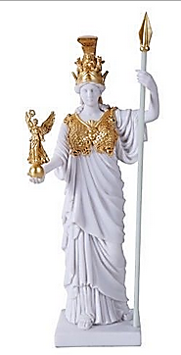

Fig. 1. This miniature statue represents Phidia’s Athena standing majestically, fully armed and holding a 4-cubit tall statue of Nike in her right hand.

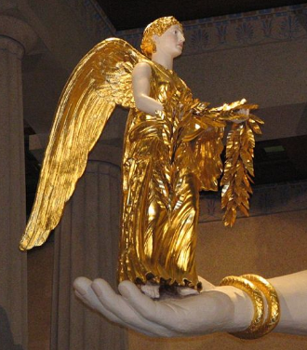

Fig. 2. The statue of Nike in Athena’s hand was also much copied, notably in a full-size copy from Cyrene now in Philadelphia.

Athena wore a *peplos*. She held a large spear in her left hand which rests on the floor. On her triple-crested helmet stood a sphinx and two griffins with Pegasus wings either side; griffins also decorated the cheek-pieces. On the goddess’ chest was the snake-tasselled aegis given to her by Zeus with the head of the gorgon. The Athena statue was removed when Greece adopted Christianity and converted the Parthenon into a church; the statue's fate is unknown. Later, the Parthenon served as a munitions storage depot, and a medieval explosion reduced it to the ruins seen today.

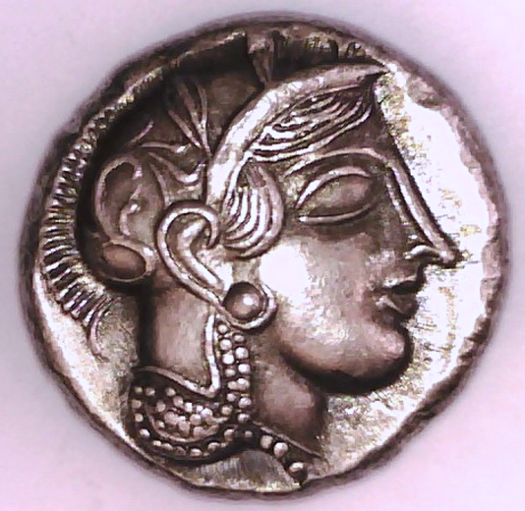 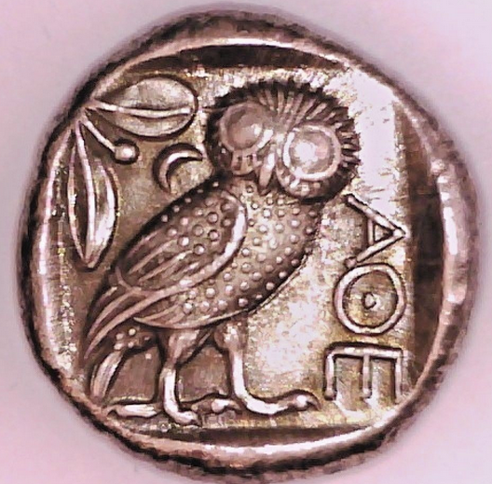

Fig.3. This is the famous Attica Tetradrachm known as the “Owl Coin” that represented Phidias’s Athena Parthenos. Obv.: Head of Goddess Athena, Rev. Owl standing. Diameter: 25 mm.

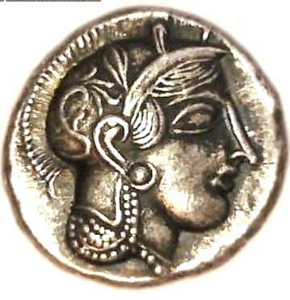 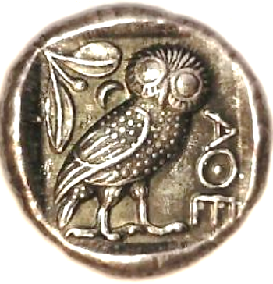

Fig. 4. Another copy of the famous Attica Tetradrachm known as the “Owl Coin” that represented Phidias’s Athena Parthenos. Obv.: Head of Goddess Athena, Rev. Owl standing. Diameter: 25 mm.

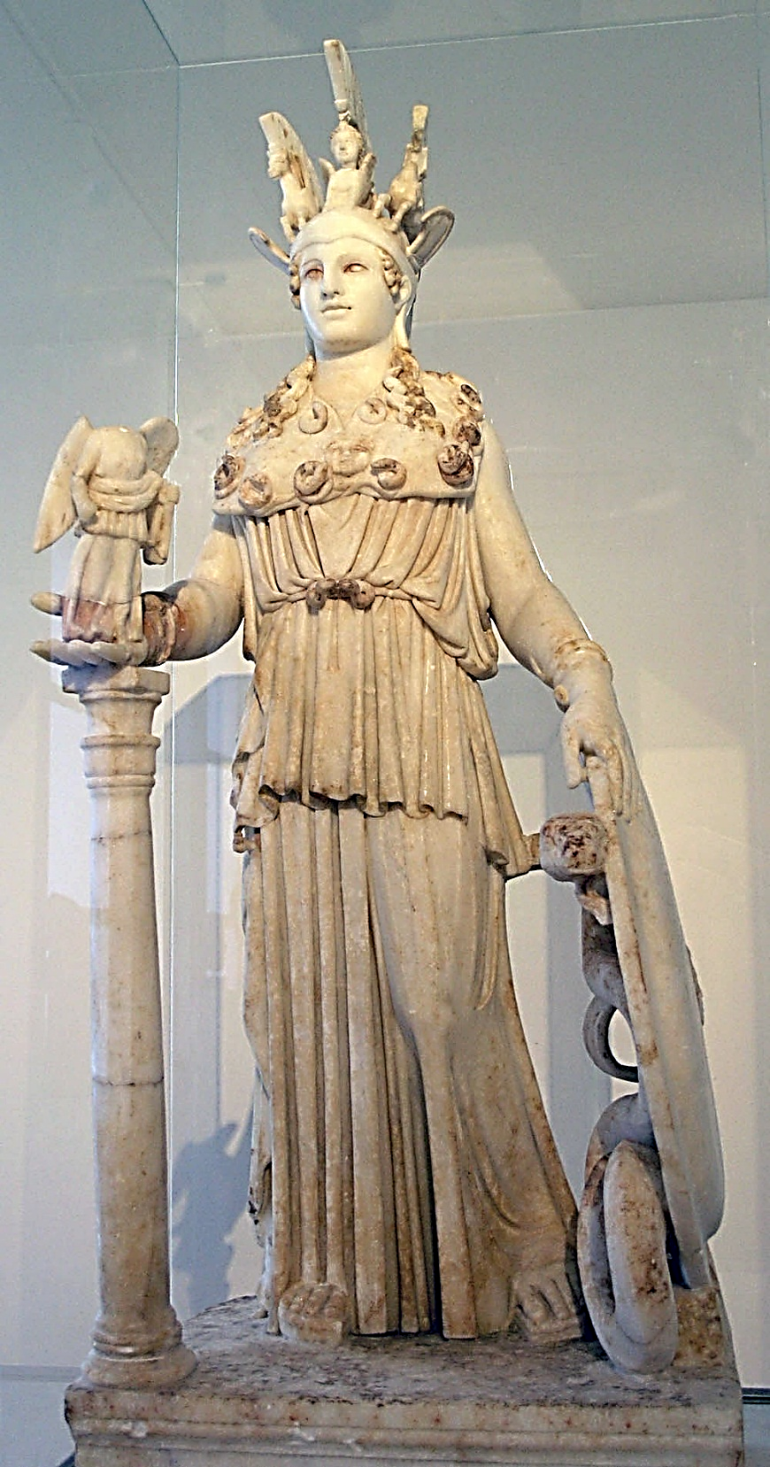

Fig. 5. The Varvakeion Athena reflects the type of the restored *Athena Parthenos*: Roman period, 2nd century CE (National Archaeological Museum of Athens). Athena Varvakeion, small Roman replica of the Athena Parthenos by Phidias. Found in Athens near the Varvakeion school, hence the name. First half of the 3rd c. CE. This is considered the best preserved and most complete representation of Pheidias’ lost masterpiece which is a 1.05 m tall Roman copy in marble from the 2nd century CE and which now resides in the National Archaeological Museum of Athens.

Other full figures, albeit with some damage, include the ‘Lenormant statuette’, another Roman copy, 2nd or 3rd century CE, 42 cm tall (also in Athens); the 86 cm tall ‘Patras statuette’ (in Patras); a 1.54 m tall figure now in the Boston Museum of Fine Arts, and a Hellenistic version from Pergamon which is 3.1 m tall and preserves some partial figures on the base (Berlin).

Detailed depictions of the head appear on a 2nd c CE Emeryk Hutten-Czapski Palace in Kraków

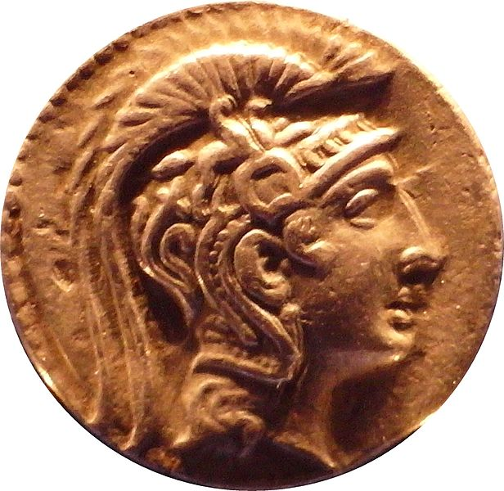

Fig. 6. Gold medallion, 126-125 BCE, head of the sculpture of Athena Parthenos by Phidias in the Emeryk Hutten-Czapski Palace in Kraków. Image taken by [Mathiasrex](https://commons.wikimedia.org/wiki/User:Mathiasrex), Maciej Szczepańzyk from <https://upload.wikimedia.org/wikipedia/commons/thumb/f/fd/Tetradrachm_of_Athens>

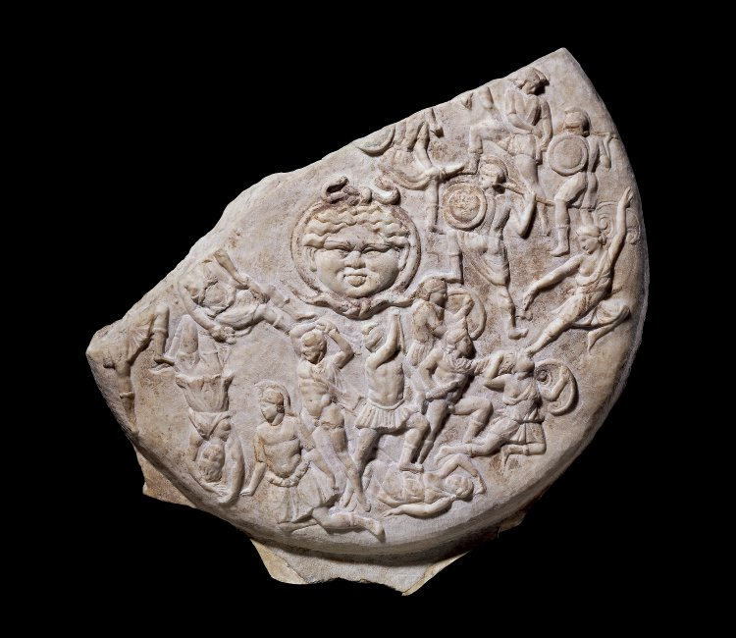

Fig. 7. A 3rd century Roman marble copy of the shield is the so-called ‘Strangford shield’, named after its owner Lord Strangford, now in the British Museum, London . BM Acc. No. 1864,0220.18.

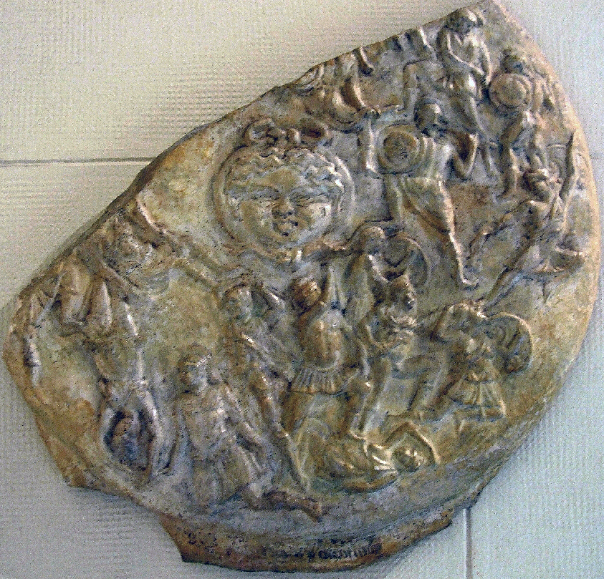

Fig. 8. Plaster cast of the so-called "Strangford Shield" in the Pushkin Museum, Moscow. After shako 2009.

Phidias and Pericles are shown as two men standing back-to-back below the central mask of a gorgon: Phidias the balding figure on the left with arms raised, with Pericles to the right, one foot raised on a fallen Amazon and arms raised obscuring his face from view. Traces of the original paint remain.

|  |
| --- |
| Greek pursuing a wounded Amazon (scene of Amazonomachia). Marble. Neo-Attic relief panel. Mid-2nd cent. CE. Inv. No. 2115. Athens, Archaeological Museum of Piraeus  Fig. 9. Neo-Attic marble relief panel. Mid-2nd cent. CE. Inv. No. 2115. Archaeological Museum of Piraeus (Αρχαιολογικό Μουσείο Πειραιά) |

**A**ccording to Pliny, the shield also depicted scenes from the Battles of Theseus and the Amazons on the face and the battle of the Giants on the interior. Greek victories against the symbolic Centaur and Amazons were powerful visual metaphors for a celebration of the successful defense of Greek independence and way of life against the Persians. The 30 or so figures on the shield were probably made from silver or bronze. The center was dominated by the head of Medusa, the gorgoneion, surrounded by individual duels of Greeks and Amazons striking dramatic poses against a background of landscape features and fortifications. Scenes of the Amazons are strikingly depicted on 2nd century CE Roman relief slabs from a Piraeus wreck which are now on display in the Archaeological Museum of  Piraeus.  Greek pursuing a wounded Amazon (scene of Amazonomachia).

A number of ancient reproductions of all or part of the statue have survived.

The [Varvakeion Athena](https://en.wikipedia.org/wiki/Varvakeion_Athena), a 3rd-century CE Roman copy in marble is housed in the [National Archaeological Museum of Athens](https://en.wikipedia.org/wiki/National_Archaeological_Museum_of_Athens). This is generally considered the most faithful version.

The [Lenormant Athena](https://en.wikipedia.org/wiki/Lenormant_Athena), an unfinished 2nd to 3rd century copy, is also in the National Museum, Athens.

[Another copy](https://en.wikipedia.org/wiki/File:Athena_Parthenos_Louvre_Ma91.jpg) is housed in the [Louvre](https://en.wikipedia.org/wiki/Louvre).[[13]](https://en.wikipedia.org/wiki/Athena_Parthenos#cite_note-15)

[Another copy](https://en.wikipedia.org/wiki/File:Athena_Parthenos_Altemps_Inv8622.jpg) is in the [Museo Nazionale Romano](https://en.wikipedia.org/wiki/Museo_Nazionale_Romano) in Rome.

A 3rd-century BC copy is housed in the [National Museum of Serbia](https://en.wikipedia.org/wiki/National_Museum_of_Serbia) in [Belgrade](https://en.wikipedia.org/wiki/Belgrade).[[14]](https://en.wikipedia.org/wiki/Athena_Parthenos#cite_note-16)

A 3rd-century BC Roman marble reduced-scale copy of the statue's shield, from the [Strangford Collection](https://en.wikipedia.org/wiki/Percy_Smythe,_6th_Viscount_Strangford), is conserved at the [British Museum](https://en.wikipedia.org/wiki/British_Museum).[[15]](https://en.wikipedia.org/wiki/Athena_Parthenos#cite_note-17)

A Modern Replica at Nashville was conceived to be placed in the replica of the Parthenon at Athens designed by **William Crawford Smith** (November 26, 1837 – February 5, 1899) an American architect who served in the Confederate States Army. Nashville's moniker, the "Athens of the South” influenced the choice of the Partheon as the centerpiece of the 1897 Centennial Exposition. Originally built of plaster, wood, and brick, the Parthenon was not intended to be permanent, but the cost of demolishing the structure combined with its popularity with residents and visitors alike resulted in it being left standing after the Exposition. In 1895 George Julian Zolnay was "employed to make models for the ornamentation" for the building.[[5]](https://en.wikipedia.org/wiki/Parthenon_(Nashville)#cite_note-5) Within the next 20 years, weather had defaced the landmark; it was then rebuilt on the same foundations, in concrete, in a project that started in 1920; the exterior was completed in 1925 and the interior in 1931.[[6]](https://en.wikipedia.org/wiki/Parthenon_(Nashville)#cite_note-6)

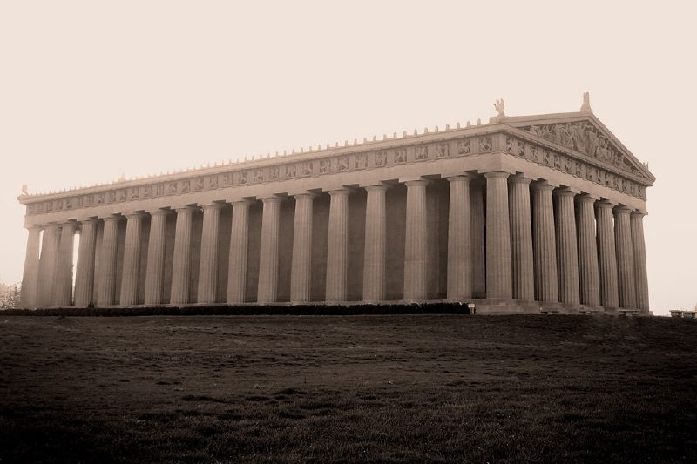

Fig. 10. The 1931 refurbishment of the Nashville Parthenon.

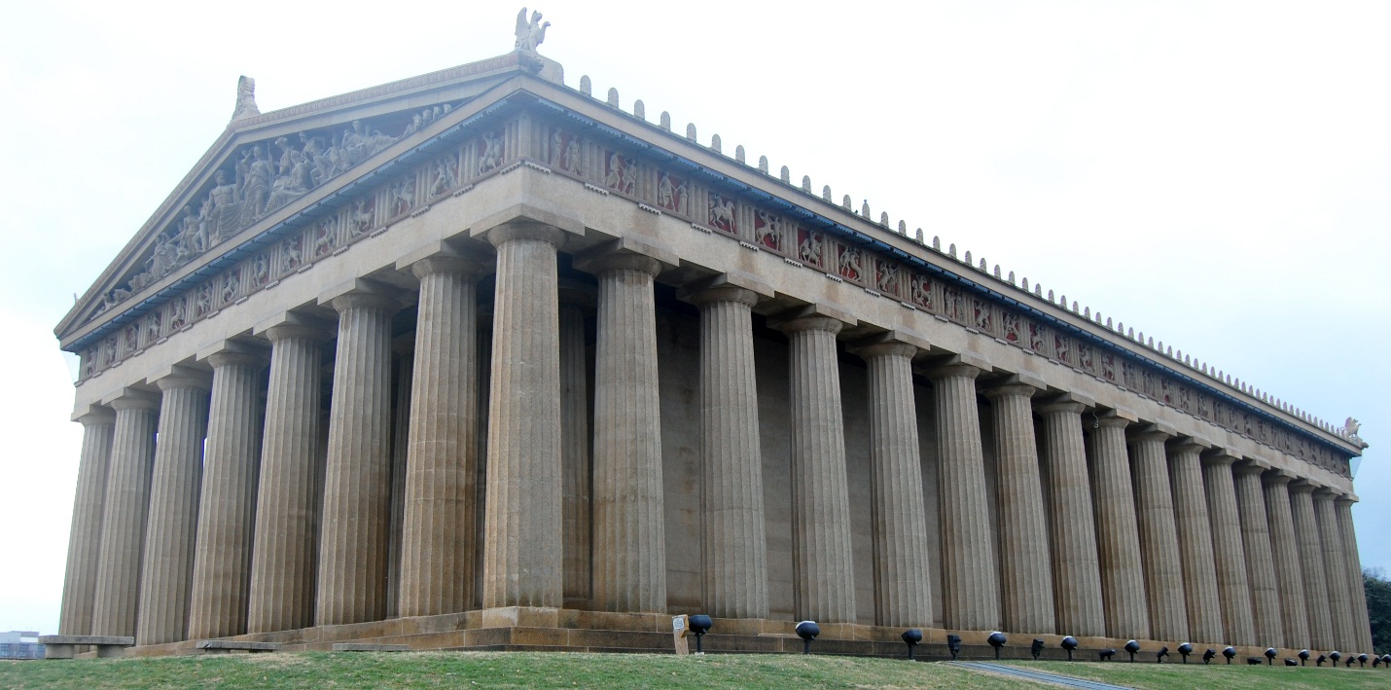Fig. 11. The refurbished Nashville Parthenon in 1990.

[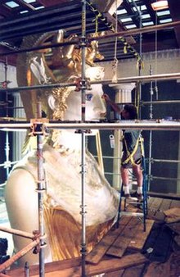](https://en.wikipedia.org/wiki/File:AthenaAlanpainting.jpg)

Fig. 12. Sculptor [Alan LeQuire](https://en.wikipedia.org/wiki/Alan_LeQuire) painting the detail of the *Athena Parthenos* replica during the gilding phase

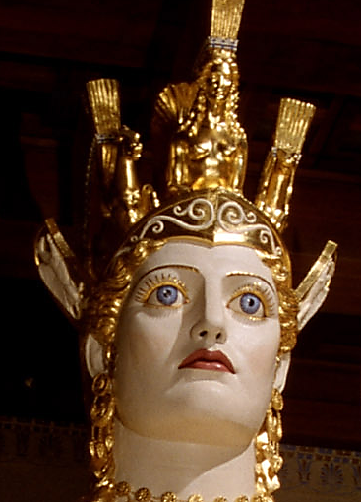

Fig.13.The detail of the *Athena Parthenos* replica during the gilding phase.

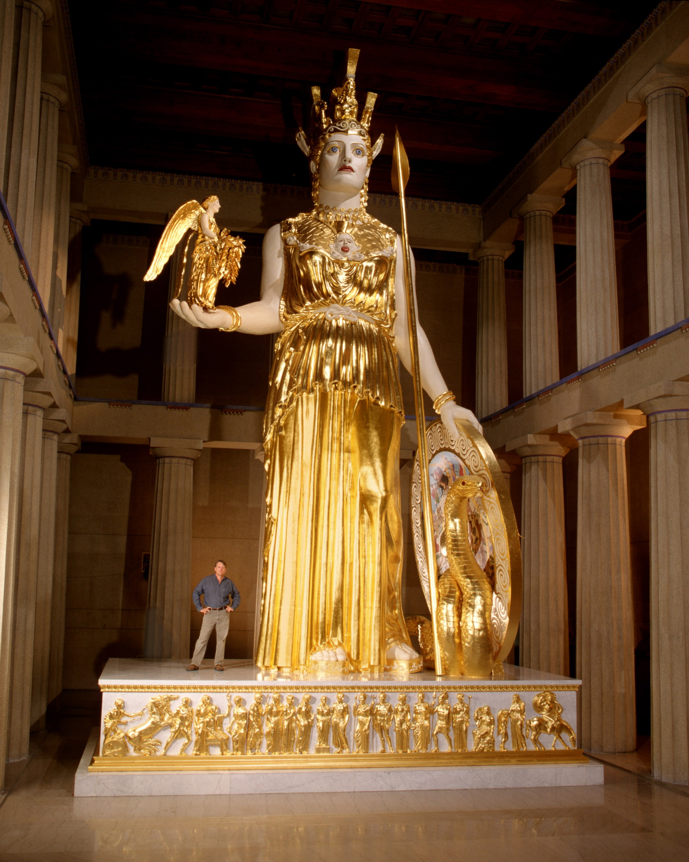 Fig. 14. The reproduction of the Parthenon in Nashville, Tennessee by Alan Le Quire. Photograph by Dean Dixon. https://upload.wikimedia.org/wikipedia/commons/thumb/0/02/Athena_Parthenos_LeQuire.jpg/720px-Athena_Parthenos_LeQuire.jpg

Le Quire, a Nashville native, was awarded the commission to produce the Parthenon's cult statue. His work was modeled on descriptions given of the original. The modern version took eight years to complete, and was unveiled to the public on May 20, 1990.

The modern version of *Athena Parthenos* is significant because of its scale and its attention to recreating Phidias' work. Interestingly enough, historians remain unsure whether or not Phidias himself actually deserves credit for the design and sculpture of the Parthenon, since during the creation Phidias' location was unknown (Spivey 1996). The statue adds an additional dimension of realism to the replicated Parthenon, whose interior east room (the *naos*) was merely a large empty hall prior to the statue's unveiling. The reproduced *Athena Parthenos* gives visitors the impression that they truly are inside an ancient place of worship.

The Nashville Athena Parthenos is made of a composite of gypsum cement and ground fiberglass. The head of Athena was assembled over an aluminum armature, and the lower part was made in steel. The four ten-inch H beams rest on a concrete structure that extends through the Parthenon floor and basement down to bedrock, to support the great weight of the statue. Le Quire made each of the 180 cast gypsum panels used to create the statue light enough to be lifted by one person and attached to the steel armature.

Nashville's Athena stands 41 ft 10 in (12.75 m) tall, making her the largest piece of indoor sculpture in the Western World (Gordon 2010: 234). It stood in Nashville's Parthenon as a plain, white statue for twelve years. In 2002, Parthenon volunteers gilded Athena under the supervision of master gilder Lou Reed. The gilding project took less than four months and makes the modern statue appear that much more like the way that Phidias' Athena Parthenos would have appeared during its time. The 23.75-karat gold-leaf on Nashville's Athena Parthenos weighs a total of 8.5 pounds (3.9 kg) and is one-third the thickness of tissue paper. The modern extravagance of gilding such a large statue pales in comparison to the lavish spending of the Greeks.

In the summertime, local theatre productions use the building as a backdrop for classic Greek plays such as Euripides' [*Medea*](https://en.wikipedia.org/wiki/Medea_(play)) and [Sophocles](https://en.wikipedia.org/wiki/Sophocles)' *Antigone*, performing (usually for free) on the steps of the Parthenon. Other performances, such as Mary Zimmerman's [*Metamorphoses*](https://en.wikipedia.org/wiki/Metamorphoses_(play)), have been done inside, at the foot of Athena's statue.

References:

Melton, J. Gordon; Baumann, Martin, 2010. Religions of the World: A Comprehensive Encyclopedia of Beliefs and Practices (2nd ed.). Santa Barbara, California: ABC-CLIO.

Spivey, Nigel Jonathan (1996). "In Search of Pheidias" in *Understanding Greek Sculpture*. London: Thames and Hudson. pp. 152–171.